Travellers

If you have returned from China, Thailand, Japan, Republic of Korea, Hong Kong, Taiwan, Singapore, Malaysia and Macau within the last 2 weeks please do not enter the surgery.
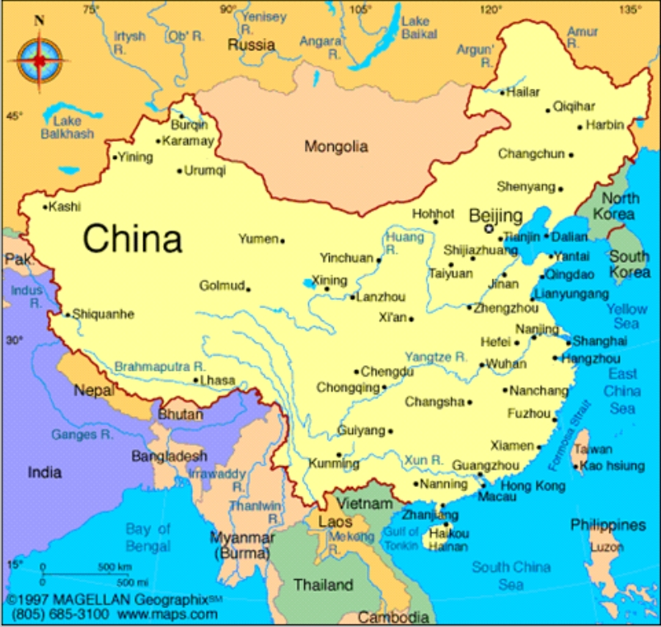
If you have chest problems:
- cough
- phlegm
- breathlessness
- aching arms or legs or neck

Then please go home and phone the surgery for advice 111. This is for us to consider the new infection which has appeared in Wuhan, Beijing and Shanghai.

If you do not have any chest problems then you can come into the surgery but please tell the receptionist that you have recently come back from China, Thailand, Japan, Republic of Korea, Hong Kong, Taiwan, Singapore, Malaysia & Macau.

Strawberry Place Surgery

